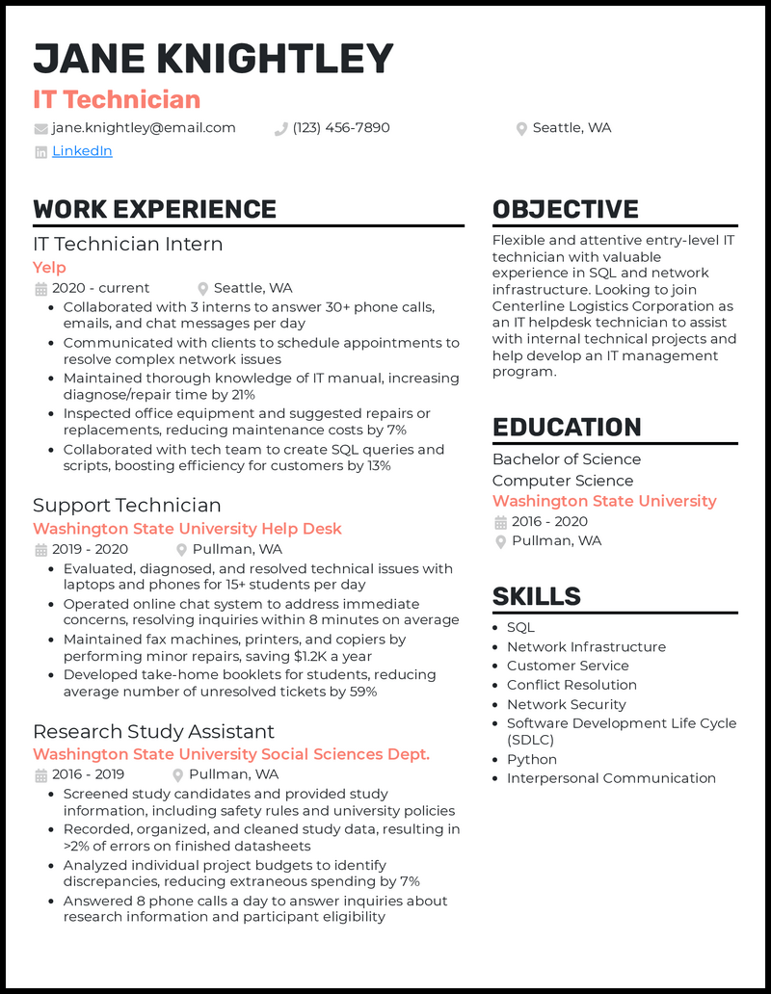
JANE KNIGHTLEY
IT Technician
jane.knightley@email.com
(123) 456-7890
Seattle, WA
in LinkedIn
WORK EXPERIENCE
IT Technician Intern
Yelp
2020 - current
Seattle, WA
• Collaborated with 3 interns to answer 30+ phone calls, emails, and chat messages per day
• Communicated with clients to schedule appointments to resolve complex network issues
• Maintained thorough knowledge of IT manual, increasing diagnose/repair time by 21%
• Inspected office equipment and suggested repairs or replacements, reducing maintenance costs by 7%
• Collaborated with tech team to create SQL queries and scripts, boosting efficiency for customers by 13%
Support Technician
Washington State University Help Desk
2019-2020
Pullman, WA
• Evaluated, diagnosed, and resolved technical issues with laptops and phones for 15+ students per day
• Operated online chat system to address immediate concerns, resolving inquiries within 8 minutes on average • Maintained fax machines, printers, and copiers by performing minor repairs, saving $1.2K a year
• Developed take-home booklets for students, reducing average number of unresolved tickets by 59%
Research Study Assistant
Washington State University Social Sciences Dept. 2016-2019 Pullman, WA
• Screened study candidates and provided study
information, including safety rules and university policies • Recorded, organized, and cleaned study data, resulting in >2% of errors on finished datasheets
• Analyzed individual project budgets to identify discrepancies, reducing extraneous spending by 7%
• Answered 8 phone calls a day to answer inquiries about research information and participant eligibility
OBJECTIVE
Flexible and attentive entry-level IT technician with valuable experience in SQL and network infrastructure. Looking to join Centerline Logistics Corporation as an IT helpdesk technician to assist with internal technical projects and help develop an IT management program.
EDUCATION
Bachelor of Science Computer Science Washington State University 2016-2020 Pullman, WA
SKILLS
SQL
• Network Infrastructure
• Customer Service
• Conflict Resolution
• Network Security
• Software Development Life Cycle (SDLC) Python
• Interpersonal Communication

